|  |  |
| --- | --- |
|  | April 27, 2022 |
| From: | Loc Nguyen |
| To: | Dr. Jeffrey Bohler |
| Subject: | Human Stress Detection in and through in sleep |

Summary:

Getting 7-9 hours of sleep each day is integral to maintaining optimum mental and physical health. Stress refers to a state of physical and emotional tension emanating from a thought or event that makes an individual feel nervous, angry, or frustrated. According to Martire et al. (2020), stress and sleep have a bi-directional relationship with stress-causing lack of sleep in individuals. It then causes a cycle of worrying about one's lack of sleep, leading to more sleepless nights until it impacts one's mental and physical health. Rachakonda, Bapatla, Mohanty & Kougianos (2021) investigates the relationship between sleep and stress using nine biological variables. The study shows that stressed individuals have a low body temperature below 90◦F, heightened limb and eye movement, and higher respiration and heart rates. Highly stressed individuals get between five and two hours of sleep each night, with some getting no sleep. Based on the study results, the authors recommend the Smart-Yoga Pillow, which materializes the idea of smart sleeping. SaYoPillow comes with an edge processor capable of recording, analyzing, and storing psychological changes during sleep using IoT cloud storage and proposes good sleeping habits (Rachakonda et al., 2018). The authors also propose that the SaYoPillow should have security features to ensure safe data transfer and consider sleeping habits that reduce stress by up to 96%.

Customer Question:

How can SaYoPillow improve one's sleep quality and reduce the stress associated with the following day?

Data:

The dataset provided by Rachakonda and the company contains eight psychological variables. These include snoring range, respiration range, body temperature, limb movement, blood oxygen level, eye movement, sleep hours, heart rate, and individual stress level. Stress is measured as a categorical variable with 0 being low or normal stress, 2 being medium, three medium-high stress, and four indicating high-stress levels. The SaYoPillow dataset shows the participants have medium stress levels (2) with a standard error of 0.056. The most recurrent participant response to the variable is three, which indicates medium-high stress levels. Based on the dataset, the average sleeping hours for participants was 3.7 hours which is below the recommended sleeping time of 7-9 hours (Martire et al., 2020). The sleeping time variable varied greatly among participants, with a range of 9 hours between the highest and lowest recorded readings. The dataset shows a distinct relationship between stress and sleeping hours, with stress increase causing lower sleeping times among participants, as shown in Appendix A. Similarly, the participants showed heightened snoring and respiration range, eye and limb movement, and an increased heart rate with means of 71.6, 21.8, 11.7, 88.5, and 64.5 respectively. Conversely, the participants showed lower body temperature and blood oxygen levels with averages of 92.8◦F and 90.9, which is conversant with individuals having medium-high stress levels.

Analysis:

The SaYoPillow aims to materialize smart sleeping by minimizing the current and subsequent day's stress. We need to establish a relationship between the different psychological variables recorded and an individual's stress level. I established this relationship by running linear regression on the dataset. The stress level was the dependent variable, while SR, RR, T, LM, BO, REM, DR, and HR were the independent variables. Similarly, I conducted an ANOVA analysis to determine if there exist any statistically significant differences between the nine variables. I used the hypothesis.

H0: µ1= µ2= µ3= µ4= µ5= µ6= µ7= µ8=µ9

H1: µ1≠ µ2≠ µ3≠ µ4≠ µ5≠ µ6≠ µ7≠ µ8≠ µ9

Results

Regression analysis is a form of inferential statistics which produces p-values that show if the larger population also experiences the attributes exhibited by the sample. The linear regression analysis conducted on the data produces 0 and negative p-values, making the variables statistically significant. Therefore, there is sufficient evidence to conclude that the variables have a non-zero correlation, and that model produces precise estimates. Coefficients show the relationship between the independent and dependent variables, as shown in Appendix B. The analysis gives us a regression equation of Stress Level=7.48+0.0096SR-0.164T-0.08LM+0.05BO+0.03REM-0.11SR+0.05HR.

The respiration range shows a 0 correlation with stress level and thus should be removed to get more precise results. Similarly, ANOVA analysis conducted on the data gives us a p-value of 0, which is less than our significance level of 0.05, as shown in Appendix C. Therefore, we reject the null hypothesis and conclude that not all variable means are equal.

Impact:

The study establishes that individual stress level impacts their quality of sleep. Participants with high-stress levels experienced heightened snoring range, heart rate, and eye and limb movement (Rachakonda et al., 2021). Conversely, they had low body temperature, blood oxygen range, and lower sleeping hours. Most of the participants had medium-high stress levels indicating that this is a recurrent issue experienced by most.

Recommendation:

The analysis establishes a negative relationship between sleeping hours and high-stress levels resulting in less sleep. According to Kalmbach, Anderson & Drake (2018), losing a day's sleep due to stress leads to more stress for an individual and causes sleeping problems to persist. As such, developing the SaYoPillow is an emerging priority as it collects psychological data and sleeping patterns, helping an individual establish how stress affects their sleep (Rachakonda et al., 2018). The technology also gives recommendations based on the individual's sleeping habits, further materializing the idea of smart sleeping.

Maintenance:

Even after developing the SaYoPillow to improve individual sleep cycles, we still need to test its effectiveness in a real-world setting. Further research on the topic should include an experimental group that uses SaYoPillow and a control group. From the sample, we can gauge how the level of stress impacts the different groups while also measuring the effectiveness of the SaYoPillow.

References:

Kalmbach, D. A., Anderson, J. R., & Drake, C. L. (2018). Stress's impact on sleep is pathogenic sleep reactivity as a vulnerability to insomnia and circadian disorders. Journal of sleep research, 27(6), e12710.

Martire, V. L., Caruso, D., Palagini, L., Zoccoli, G., & Bastianini, S. (2020). Stress & sleep: A relationship lasting a lifetime. Neuroscience & Biobehavioral Reviews, 117, 65-77.

Rachakonda, L., Bapatla, A. K., Mohanty, S. P. & Kougianos E. (February 2021). SaYoPillow: Blockchain-Integrated Privacy-Assured IoMT Framework for Stress Management Considering Sleeping Habits. IEEE Transactions on Consumer Electronics (TCE), Vol. 67, No. 1. Pp. 20-29.

Rachakonda, L., Mohanty, S. P., Kougianos E., Karunakaran, K., & Ganapathiraju, M. (2018). Smart-Pillow: An IoT-based Device for Stress Detection Considering Sleeping Habits. IEEE International Symposium on Smart Electronic Systems (SES). Pp. 161--166

**Appendix**

**Appendix: A line graph of stress levels against sleeping hours**

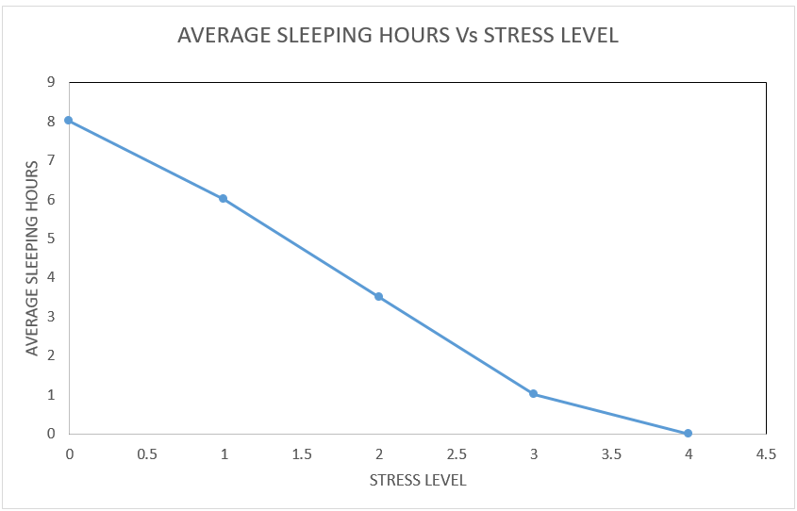

**Appendix B: Regression Analysis Output**

